**Microservices with Spring Boot 3 and Spring Cloud**

**2. Microservices with API gateway**

**Creating Microservices for account and loan**

* **ACCOUNT MICROSERVICE**

**Step 1: Folder Setup**

Create a folder with your **employee ID**, for example: D:\123456

Inside that, create another folder named microservices:  
D:\123456\microservices.

**Step 2: Generate Spring Boot Project**

1. Go to <https://start.spring.io>
2. Fill the form:
   * **Group**: com.cognizant
   * **Artifact**: account
3. Select dependencies:
   * Spring Boot DevTools (Developer Tools)
   * Spring Web (Web)
4. Click **Generate**. A ZIP file will download.

**Step 3: Extract Project**

1. Extract the ZIP.
2. Copy the extracted folder account into:  
   D:\123456\microservices

**Step 4: Build Project via Command Prompt**

1. Open **Command Prompt**.
2. Navigate to project:

cd D:\123456\microservices\account

1. Run:

mvn clean package

**Step 5: Import in Eclipse**

1. Open Eclipse.
2. Go to File > Import > Maven > Existing Maven Projects.
3. Select D:\123456\microservices\account

* **src/main/java/com/cognizant/account/controller**

**AccountController.java**

package com.cognizant.account.controller;

import org.springframework.web.bind.annotation.*;

import java.util.Map;

import java.util.HashMap;

@RestController

@RequestMapping("/accounts")

public class AccountController {

@GetMapping("/{number}")

public Map<String, Object> getAccountDetails(@PathVariable String number) {

Map<String, Object> response = new HashMap<>();

response.put("number", number);

response.put("type", "savings");

response.put("balance", 234343);

return response;

}

}

* **AccountApplication.java**

package com.cognizant.account;

import org.springframework.boot.SpringApplication;

import org.springframework.boot.autoconfigure.SpringBootApplication;

@SpringBootApplication

public class AccountApplication {

public static void main(String[] args) {

SpringApplication.*run*(AccountApplication.class, args);

}

}

* **OUTPUT:**

In your browser, open:

<http://localhost:8080/accounts/00987987973432>

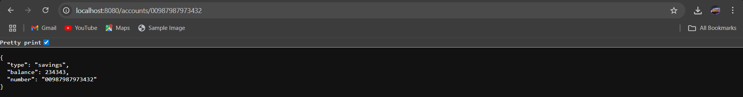

* **LOAN MICROSERVICE**

**Step 1: Generate Spring Boot Project for Loan**

1. Go to <https://start.spring.io>
2. Fill out the form:
   * Group: com.cognizant
   * Artifact: loan
3. Dependencies:
   * Spring Boot DevTools
   * Spring Web

**Step 2: Extract & Organize**

1. Extract the ZIP.
2. Place the loan folder into:

D:\YourEmployeeId\microservices\

**Step 3: Build Using Command Prompt**

Open **CMD**:

cd D:\123456\microservices\loan

mvn clean package

**Step 4: Import Loan Project in Eclipse**

1. Open Eclipse.
2. Go to: File > Import > Maven > Existing Maven Projects
3. Select D:\123456\microservices\loan

**Step 5: Set Port to 8081**

1. In src/main/resources, create/edit file application.properties.
2. Add:

server.port=8081

* **com.cognizant.loan.controller**

**LoanController.java**

package com.cognizant.loan.controller;

import org.springframework.web.bind.annotation.*;

import java.util.HashMap;

import java.util.Map;

@RestController

@RequestMapping("/loans")

public class LoanController {

@GetMapping("/{number}")

public Map<String, Object> getLoanDetails(@PathVariable String number) {

Map<String, Object> response = new HashMap<>();

response.put("number", number);

response.put("type", "car");

response.put("loan", 400000);

response.put("emi", 3258);

response.put("tenure", 18);

return response;

}

}

* **LoanApplication.java**

package com.cognizant.loan;

import org.springframework.boot.SpringApplication;

import org.springframework.boot.autoconfigure.SpringBootApplication;

@SpringBootApplication

public class LoanApplication {

public static void main(String[] args) {

SpringApplication.*run*(LoanApplication.class, args);

}

}

* **OUTPUT:**

Test in Browser:

<http://localhost:8081/loans/H00987987972342>

